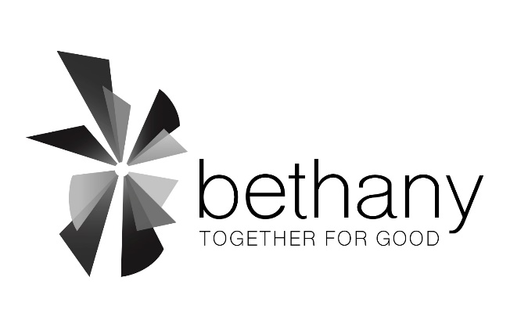

Name(s) / Address / Phone / email

________________________________________________
Bethany Lutheran Church
4500 E. Hampden Avenue
Cherry Hills Village, CO 80113
303.758.2820
www.bethany-denver.org

____________________________________________

____________________________________________

____________________________________________

____________________________________________

____________________________________________

In this year, 2023, I/we intend to express generosity to Bethany Lutheran Church by giving to the Bethany Fund.

Please check one of the three options below:

____ I have entered my 2023 commitment on Realm and have adjusted my giving.

____ I authorize the Gifts Processor to make this giving change in Realm
effective as soon as possible.
My total gift for 2023 will be $ ____________, with ___________ to be given:
Weekly ___ Quarterly ___
Monthly ___ Annually ___

____My total gift for 2023 will be $____________to be given:
Weekly ___ Quarterly ___
Monthly ___ Annually ___
Other: _______________________
This represents an increase in my giving from last year. Yes ___ No ___

To assist in receiving your gifts, check those that apply:
__ Please contact me to set up easy electronic giving in Realm, which saves administrative costs,
is environmentally friendly, and efficient!
Email: _________________________________________________________________________
__ Please discontinue sending weekly or monthly envelopes as my giving will occur electronically.
__ Please send me monthly giving envelopes.

Signed ___________________________________________ Date ____ / ____ / ___________

